DAY 2: INITIAL SETUP & BASIC AUTHENTICATION

Focus: Foundation Setup and Core Authentication System

Issues Identified Before Development:
No existing codebase or project structure
Need for secure user authentication system
Database integration requirements
Basic device management framework needed

Development Activities
Project Structure Setup:
iotsmarthomedashboard/
├── src/main/java/com/smarthome/
│ ├── SmartHomeDashboard.java
│ ├── model/
│ │ ├── Customer.java
│ │ └── Gadget.java
│ ├── service/
│ │ ├── CustomerService.java
│ │ ├── GadgetService.java
│ │ └── SmartHomeService.java
│ └── util/
│ ├── DynamoDBConfig.java
│ └── SessionManager.java
└── pom.xml

Java Files Implemented:
SmartHomeDashboard.java: Main application entry point with console menu system
Customer.java: Customer Entity Model with security features
CustomerService.java: Authentication and user management service

Features Implemented:
Authentication System:
1. User Registration
Email validation and uniqueness check
Password strength validation against common passwords
BCrypt password encryption
Automatic account creation in database

2. User Login
Email and password authentication
Failed login attempt tracking
Account lockout mechanism after 5 failed attempts
Session management

3. Security Features
Password hashing using BCrypt with salt
Account lockout for 15 minutes after failed attempts
Common password detection and rejection
Secure session state management

Device Management Foundation:
1. Basic Device Support
TV, AC, Fan, Robotic Vacuum/Mop devices
ON/OFF status control
Roombased device organization
Device model and type tracking

Testing Results:
Manual testing of registration flow: PASSED
Manual testing of login flow: PASSED
Database connectivity test: PASSED
Basic device operations test: PASSED

Testing Screenshots:
Main Menu:
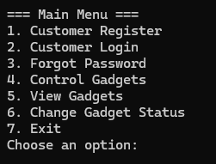

Registration test:
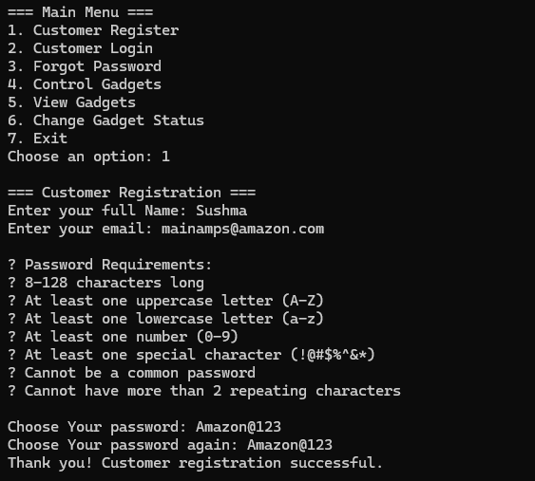

Registration with previously registered user data:
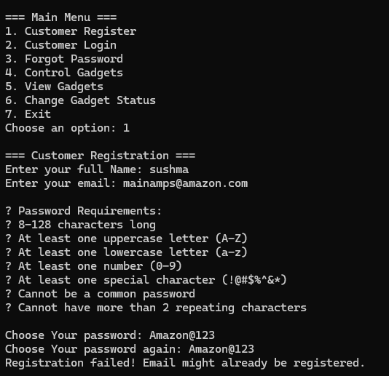

Password Strength test:
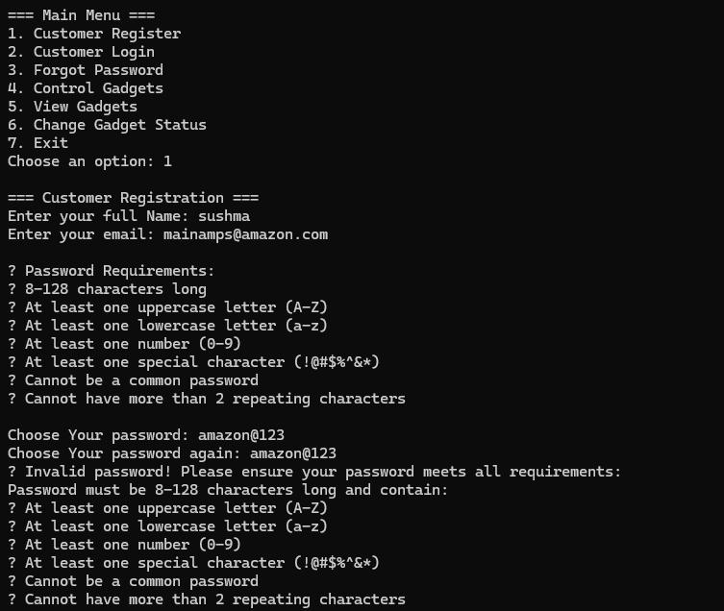

Login test:
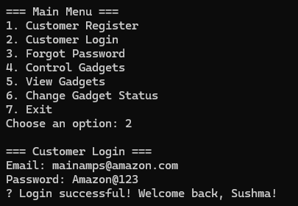
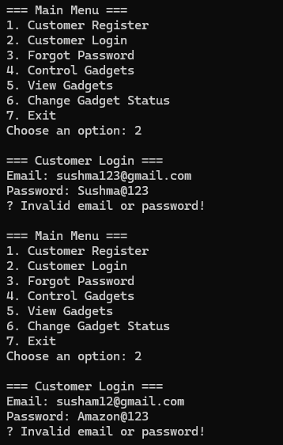

Conclusion Day 2:
Successfully established the foundation IoT Smart Home Dashboard with secure authentication system and basic device management. Implemented robust password security with BCrypt encryption and account lockout mechanisms.

Key Achievements:
Complete project structure setup
Secure user authentication system
Basic device management framework
Database integration with DynamoDB
Foundation for future feature expansion

